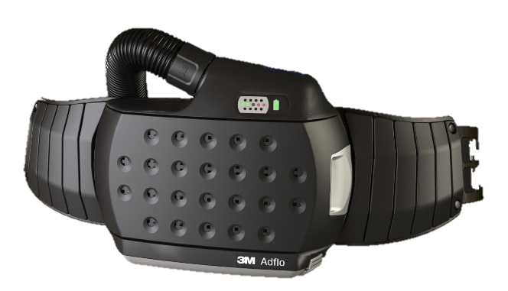
3M™ Adflo™
Powered Air Respirator

Product Description
- NPF of up to 500 (TH3)
- Can be used specifically for high efficient particle filtration (only) or for the filtration of both particulates and gases, depending on filter selection
- Cannot be used to protect against substances with poor warning properties (taste/ smell)
- Provides constant nominal airflow rate of either 170 lpm or 200 lpm (based on user settings)
- The 3M Adflo Powered Air Respirator is designed for use above sea level approximately 0-3000 m (1500 m with gas filter) and has integrated automatic altitude compensation to adjust for changes in air density.
- The respirator’s slim turbo design allows highly mobile use
- Particle filter indicator
- Battery indicator
- Robust solution

Applications
3M™ Adflo™ Powered Air Respirator is a breathing protection
device, for increased comfort and safety during welding and allied processes when used as a system in combination with approved head tops (see reference table).

Approvals
The PPE is CE marked and in conformity with the European PPE Regulation, directives and harmonized European Standards as listed in fig below, which also contain information about the Notified Body that have issued the EU type-Examination certificate for the PPE (Module B) and when applicable, the Notified Body responsible for the surveillance of the quality system of the manufacturing of
the PPE (Module D). The EU type-examination Certificates and Declaration of Conformity are available at www.3M.com/welding/certs.

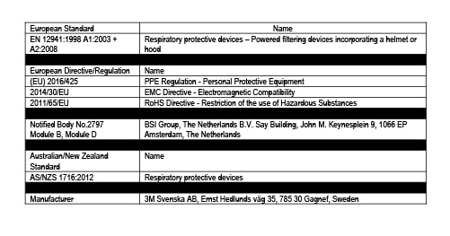

Equipment marking
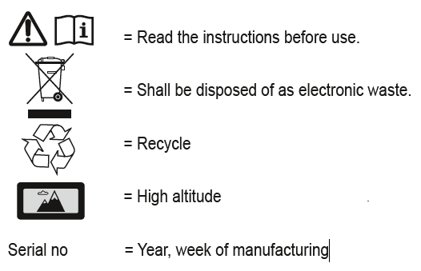

Limitations of use
- Only use with original 3M spare parts and accessories listed in the reference leaflet and within the usage conditions given in the Technical Specification
- The use of substitute components, decals, paint or other modifications not specified in these user instructions might seriously impair protection and may invalidate claims under the warranty or cause the product to be noncompliant with protection classifications and approvals.
- 3M Adflo Powered Air Respirator must not be used in the power OFF state since a rapid build-up of carbon dioxide and depletion of oxygen within the head top may occur.
- Do not remove the headtop or turn off 3M Adflo Powered Air Respirator until you have vacated the contaminated area. In the power OFF state little or no respiratory protection is expected
- Do not use for respiratory protection against unknown atmospheric contaminants or when concentrations of contaminants are unknown or immediately dangerous to life or health (IDLH).
- 3M™ Adflo™ Powered Air Respiratory System must not be used if 3M Adflo Powered Air Respirator does not supply enough air (low flow alarm).
- 3M Adflo Powered Air Respiratory System must not be used in flammable or explosive environments.
- Note that the breathing tube might make a loop and get caught up by something in the surrounding area.
- If you are not sure about the concentration of contaminant, or about equipment performance, seek advice from an industrial safety engineer. The manufacturer is not responsible for injury following incorrect use or incorrect choice of equipment.

Technical specifications
Respiratory protection class See reference leaflet
Manufacturer’s minimum
design flow rate 160 l/min
Nominal airflow app. 170 l/min
Airflow Plus app. 200 l/min
Belt size 75-127 cm
Operating conditions: -5°C to +55°C, RH ≤ 90%, noncondensing conditions
Storage conditions: -20°C to +55°C, RH ≤ 90%, non-condensing conditions
Extended period of storage: -20°C to +35°C, RH ≤ 90%, non-condensing conditions.
Batteries need regular recharging during storage for extended
periods.
Weight, 3M Adflo Powered
Air Respirator
(incl. P-filter, excl. battery) 705 g
Expected service life: 5 years depending on conditions of use

Spare parts, accessories and consumables
53 35 05 Adapter for non-QRS breathing tubes when using Speedglas 9100 Series welding shields
50 35 06 Adapter for QRS breathing tubes when using Speedglas 9000 Series welding shields
79 01 01 Product carry bag
83 31 01 Battery charger NiMH
83 31 11 Battery charger Li-ion
83 32 06 6-station battery charger NiMH
83 40 09 Breathing tube with silencer (118 cm), with QRS connection
83 40 16 Breathing tube, self-adjusting (52,5 to 85 cm), with QRS connection
83 40 17 Breathing tube, heavy-duty rubber with (77±5 cm), QRS connection
83 40 18 Flame resistant breathing tube cover
83 40 19 Breathing tube, self-adjusting (60 to 118 cm), with QRS connection
83 45 00 Gasket for non-QRS breathing tubes
83 50 00 Belt
83 50 05 Front part, belt
83 50 10 Quick connection for belt
83 50 20 Braces
83 60 00 Spark arrestor
83 60 10 Prefilter, pkg. of 5
83 60 80 Prefilter, pkg. of 80
83 70 00 Storage bag
83 70 10 Particle filter P SL
83 70 12 Particle filter P SL, pkg. of 2
83 70 20 Particle filter P SL, pkg. of 20
83 70 80 Particle filter P SL, pkg. of 80
83 71 10 Odour filter
83 71 20 Odour filter pad
83 72 42 Gas filter A1B1E1
83 73 00 Gas filter kit: A1B1E1 filter and Heavy-Duty battery
83 75 42 Gas filter A2
83 76 20 Battery (standard) NiMH
83 76 21 Battery Heavy-Duty NiMH
83 76 30 Battery (standard) Li-ion
83 76 31 Battery Heavy-Duty Li-ion
83 80 20 Airflow indicator
83 80 31 Filter cover

